|  |  |  |
| --- | --- | --- |
| **REPUBLIC OF CAMEROON**  **MINISTRY OF HIGHER EDUCATION**  **Peace-Work-Fatherland** |  | **REPUBLIC DU CAMEROUN**  **MINISTERE DE L’ENSEIGNEMENT SUPERIEUR**  **Paix-Travail-Patrie** |

**UNIVERSITY OF BUEA**

**FACULTY OF ENGINEERING AND TECHNOLOGY**,

**CEF440:**

**INTERNET PROGRAMMING AND MOBILE PROGAMING**

**GROUP 23: TASK 5**

|  |  |
| --- | --- |
| Names | Matriculation Number |
| NDIFON LEMUEL ASHU-MBI | FE21A247 |
| NGWASIRI RYAN TANIFIORM ONGA | FE21A266 |
| NJIDDA SALIFU | FE21A272 |
| ASONGNKWELLE COURAGE AYIM | FE21A142 |
| NKWO BRAINIE NGONDA | FE21A282 |

Course Instructor: May, 2024

Dr. Nkemeni Valery

**Table of Content**

1 Introduction…………………………………………………………………………………….1

1.1. Project Overview 3

2.1. Figma as the Design Tool 4

2.2. Key Features of Figma: 4

3. Design Methodologies Used 5

i. User-Centered Design (UCD): 5

ii. Iterative Design and Prototyping: 5

iii. Accessibility and Inclusivity: 5

iv. Design System Approach: 5

4. UI/UX Design Principles......................................................................................................................................5

a) Simplicity and Clarity 6

b) Consistency 6

c) Accessibility 6

d) Feedback and Response 6

f) Efficiency 7

g) Error Prevention and Recovery 7

h) Aesthetics and Minimalism 7

5. UI/UX Designs of Screens and Functions for Fingerprint App..........................................................................8

I. Intro Screens 8

II. Mode Screen 10

III. Admin Screens 11

IV. Student Screens 16

6. Conclusion.........................................................................................................................................................17

1. **Introduction**

Creating a student fingerprint attendance app requires a thoughtful approach to UI/UX design to ensure the application is both functional and user-friendly. At its core, the app must facilitate the seamless and secure recording of student attendance through fingerprint recognition technology. To achieve this, the design must prioritize ease of use, accessibility, and efficiency.

The UI (User Interface) should be intuitive, offering a clean and straightforward layout that guides users through the attendance process with minimal effort. Key elements like fingerprint scanning, attendance logs, and notifications should be easily accessible. Aesthetically, the design should be visually appealing yet simple, avoiding clutter while using colors and typography that enhance readability and user experience.

The UX (User Experience) focuses on the overall feel of the app and how users interact with it. This includes ensuring that the fingerprint scanning process is quick and reliable, reducing the time taken for each student to register their attendance. The app should provide immediate feedback, such as confirmation messages or error notifications, to keep users informed about the status of their attendance record.

Furthermore, the app should be designed with accessibility in mind, accommodating a wide range of users, including those with disabilities. This could involve features like voice commands, adjustable text sizes, and compatibility with various devices and screen sizes.

By integrating robust security measures, such as encryption of fingerprint data and secure user authentication, the app can protect sensitive information while maintaining compliance with data protection regulations.

In essence, the UI/UX design of a student fingerprint attendance app must blend functionality with user-centric design principles to create a seamless, efficient, and secure experience for all users.

* 1. **Project Overview**

The Student Fingerprint Attendance App project aims to streamline and modernize the process of recording student attendance in educational institutions. By utilizing fingerprint recognition technology, the app ensures accurate and secure attendance tracking, eliminating the potential for errors and fraud associated with traditional methods such as manual entry or swipe cards.

The app features an intuitive user interface (UI) designed for ease of use by students, teachers, and administrative staff. Key functionalities include:

* **Fingerprint Scanning:** Students can quickly and securely mark their attendance using fingerprint scanners. The app supports various fingerprint scanning devices to ensure broad compatibility.
* **Attendance Records:** Teachers and administrators can access real-time attendance records, with options to view, edit, and generate reports. This feature aids in monitoring student attendance patterns and identifying irregularities.
* **Data Security:** The app employs robust security measures to protect sensitive biometric data, including encryption and secure authentication protocols.

Overall, the Student Fingerprint Attendance App enhances the efficiency and accuracy of attendance management, providing a modern solution that benefits students, educators, and administrators alike.

1. **Design Tools used and Methodology**

The development of the Student Fingerprint Attendance App leverages Figma as the primary design tool, employing a range of modern design methodologies to ensure a user-centric and efficient application. This report outlines the key features of Figma and the design methodologies used in creating the app.

* 1. **Figma as the Design Tool**

Figma is a powerful, web-based design tool that facilitates collaborative interface design and prototyping. Its features make it ideal for developing complex applications like the Student Fingerprint Attendance App.

* 1. **Key Features of Figma:**
* **Real-Time Collaboration:** Figma allows multiple designers and stakeholders to work simultaneously on the same project, enhancing teamwork and speeding up the design process.
* **Cloud-Based Platform:** As a cloud-based tool, Figma ensures that designs are always up-to-date and accessible from any device, making it convenient for remote teams.
* **Prototyping and Interaction Design:** Figma supports creating interactive prototypes, enabling designers to simulate user flows and test the usability of the app before development.
* **Component Libraries:** Designers can create reusable components, ensuring consistency across the app’s interface and facilitating efficient updates and iterations.
* **Design Systems:** Figma supports the development and management of comprehensive design systems, promoting standardization and coherence in the app’s visual and functional design.

1. **Design Methodologies Used**

The development of the Student Fingerprint Attendance App follows several key design methodologies, focusing on user-centered design, iterative development, and accessibility.

1. **User-Centered Design (UCD):**

* **User Research:** Conducting interviews, surveys, and usability testing with students, teachers, and administrators to gather insights and understand their needs and pain points.
* **Personas and User Journeys:** Creating detailed personas and mapping out user journeys to guide the design process and ensure the app meets the needs of its target users.

1. **Iterative Design and Prototyping:**

* **Wireframing:** Developing low-fidelity wireframes to establish the app’s basic structure and layout.
* **High-Fidelity Mockups:** Creating detailed, high-fidelity mockups in Figma to visualize the final design.
* **Usability Testing:** Testing prototypes with real users to gather feedback and identify areas for improvement.
* **Iterative Refinement:** Continuously refining the design based on user feedback and testing results, ensuring the app evolves to meet user expectations.

1. **Accessibility and Inclusivity:**

* **Inclusive Design Principles:** Applying inclusive design principles to ensure the app is usable by people with diverse abilities, including those with visual, auditory, or motor impairments.
* **Accessibility Features:** Implementing features such as adjustable text sizes, screen reader compatibility, and high-contrast modes to enhance accessibility.

1. **Design System Approach:**

* **Component-Based Design:** Utilizing Figma’s component library to create and manage reusable components, ensuring consistency and efficiency.
* **Style Guides and Standards:** Developing a comprehensive style guide to maintain visual coherence and standardize design elements across the app.

. Figma’s robust features facilitate collaborative design and rapid prototyping, ensuring the app meets the needs of its users and delivers a seamless user experience.

1. **UI/UX Design Principles**
2. **Simplicity and Clarity**

* **UI Design**: The app's interface is designed to be straightforward and uncluttered. Essential functions like fingerprint scanning, attendance logs, and notifications are easily accessible, reducing cognitive load and making navigation intuitive.
* **UX Design:** Clear instructions and feedback are provided at each step of the attendance process, ensuring users understand what actions to take and the outcomes of those actions.

1. **Consistency**

* **UI Design:** A consistent visual language is maintained throughout the app, including the use of colors, fonts, and button styles. This consistency helps users feel familiar with the app, even as they navigate different sections
* .
* **UX Design**: Consistent interaction patterns, such as swiping to mark attendance and tapping to view logs, are used throughout the app to create a predictable and user-friendly experience.

1. **Accessibility**

* **UI Design:** The app includes features like adjustable text sizes, high-contrast modes, and voice command support to cater to users with diverse abilities. These features ensure that the app is usable by everyone, including those with disabilities.
* **UX Design:** User flows are designed to be simple and direct, minimizing the number of steps required to complete tasks and making the app more accessible to users with varying levels of technical proficiency.

1. **Feedback and Response**

* **UI Design**: Immediate visual and auditory feedback is provided for key actions, such as successful fingerprint scans and error notifications. This feedback reassures users that their actions have been registered and informs them of any issues that need to be addressed.
* **UX Design:** Confirmation messages and error alerts are clear and concise, helping users understand the status of their attendance without confusion.

1. **User-Centered Design**

* **UI Design:** The interface is designed based on user research and testing, ensuring that it meets the real needs and preferences of students, teachers, and administrators. Personas and user journeys guide the design process, keeping the focus on the end-users.
* **UX Design**: Iterative testing and refinement are integral to the design process. Prototypes are tested with actual users, and their feedback is used to make continuous improvements, ensuring the app evolves to better meet user needs.

1. **Efficiency**

* **UI Design:** The design minimizes the number of steps needed to complete common tasks, such as marking attendance or viewing logs. Key actions are placed prominently and can be accessed quickly.
* **UX Design:** The app leverages automation where possible, such as auto-syncing attendance data and providing quick access to frequently used features. This reduces the time and effort required from users.

1. **Error Prevention and Recovery**

* **UI Design:** The app includes safeguards to prevent errors, such as confirming critical actions and providing clear instructions. For example, users are prompted to confirm their identity before finalizing their attendance.
* **UX Design:** In cases where errors do occur, the app offers easy ways to correct them. Clear error messages guide users on how to resolve issues, and undo options are available for actions that can be reversed.

1. **Aesthetics and Minimalism**

* **UI Design:** The aesthetic design is clean and minimalistic, avoiding unnecessary elements that could distract or confuse users. The use of whitespace and simple color schemes helps to focus attention on essential functions.
* **UX Design:** The minimalist approach extends to the overall user experience, ensuring that every element serves a purpose and enhances the usability of the app. This makes the app not only more visually appealing but also easier to use.

1. These principles guide the design process, ensuring that the app is intuitive, efficient, and accessible for all users.
2. **UI/UX Designs of Screens and Functions for Fingerprint App**
   1. **Screen Categories**
3. **Intro Screens**

These screens provide the user intuitive property increasing user friendliness and indicating the intended audience. We have three screens in general

* Splash Screen
* Welcome Screen
* Onboarding Screen

1. **Splash Screen**

The decided app name is called PrintPass



1. **Welcome Screen**

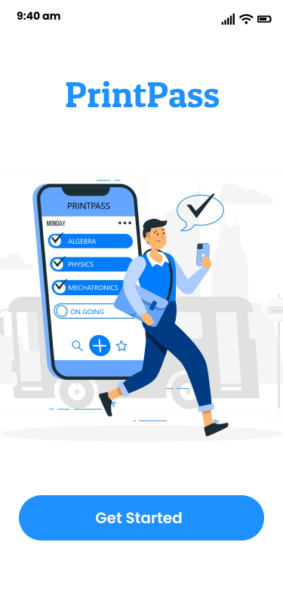

1. **Onboarding Screens**

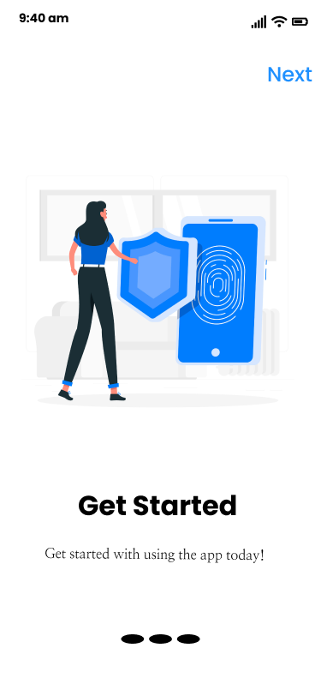

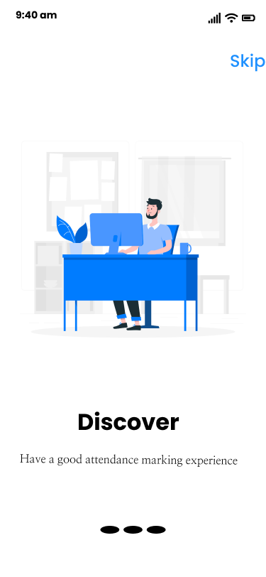

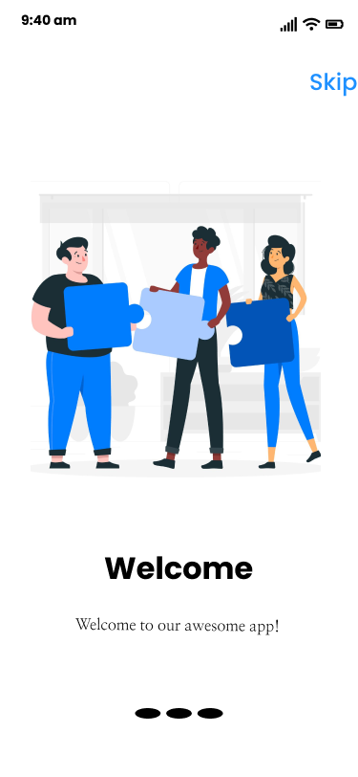

1. **Mode Screen**

The fingerprint student attendance app is a two user application that occurs between the admins and the students on the same mobile device (devices). So this screen will serve for a user to select his/her role.

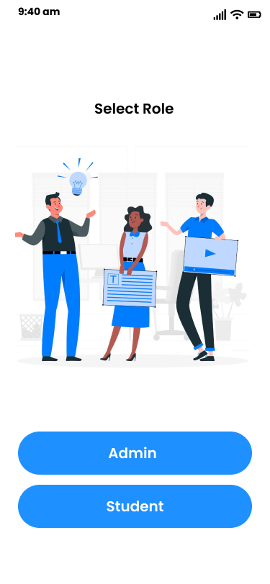

Mode Select Screen Page

1. **Admin Screens**

The admin screens seek to illustrate the user interface of all the operations that can

1. **Authentication Screens**

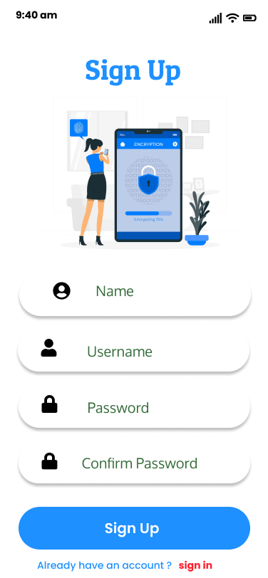

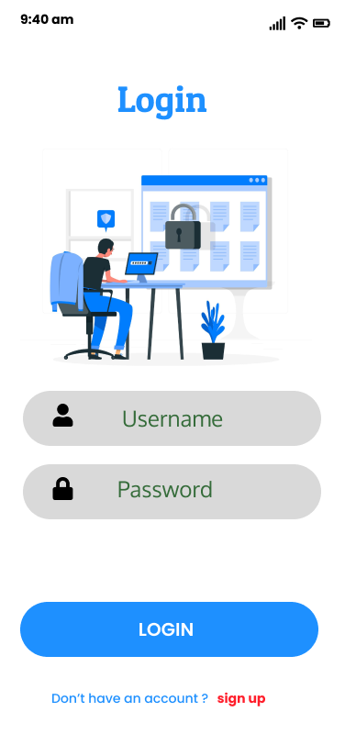

Login Screen

Sign Up Screen

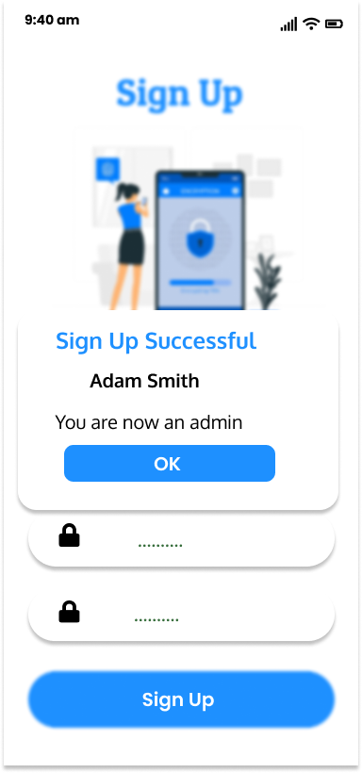

Success Login Screen

1. **Admin Dashborad**

The admin dashboard is a gateway to all admin operations in the mobile application, it contains icons that represent sessions, enroll students and report generation.

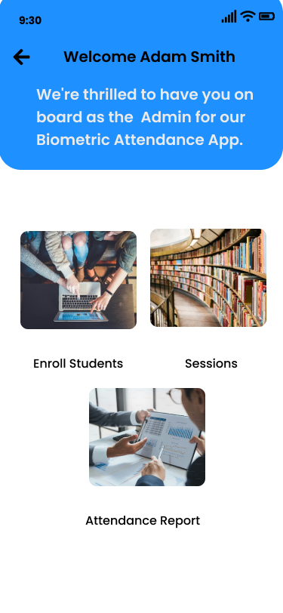

Admin Dashboard Screen

1. **Session Screens**

The session screen allows the admin perform various operations such as

* Creating sessions which comprises of the course code, course name , the day the course is taught and the time the course is taught.
* The admin can edit these sessions.
* The admin can also delete these sessions.
* View all the sessions created

Here are the screens

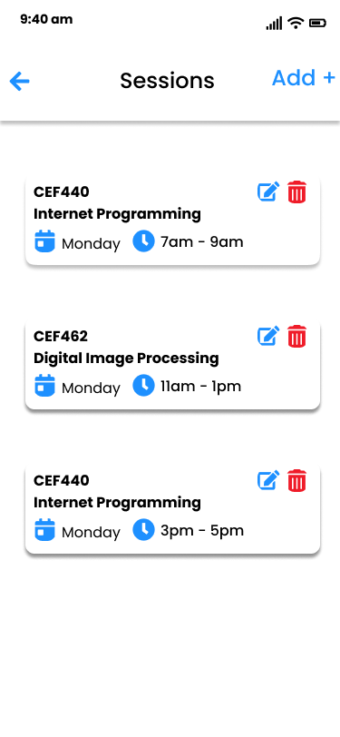



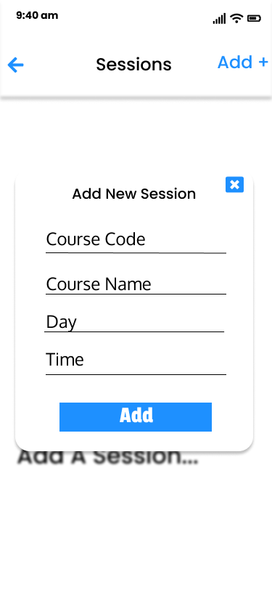

Sessions Screen

No Sessions yet Screen

Add Modal Screen

1. **Student Registration Screen**

The student registration screen permits the admin to register students in to the system.

This is done by

* Manually registering the fingerprint in the smartphone device and to do this go to Settings >Security > Fingerprint and enroll the fingerprint
* Now student credentials such as name and matricule are entered.
* Fingerprint data is registered by clicking the fingerprint icon to conclude fingerprint registration of student.
* The registration button is pressed, and on doing so student registration is done and on doing so a pop-up component appears giving the student a unique four character identifier.
* The identifier is auto-generated by the system after a student is registered making it unique to every student, the purpose of this is to ease mapping of fingerprint data to student name on attendance marking.

Here are the screens

Successful Fingerprint Registration Registration

Unique Identifier for Student

Student Registration

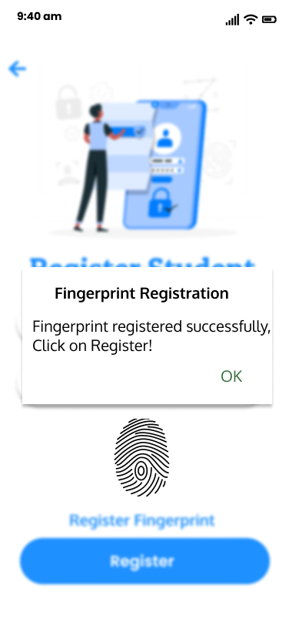

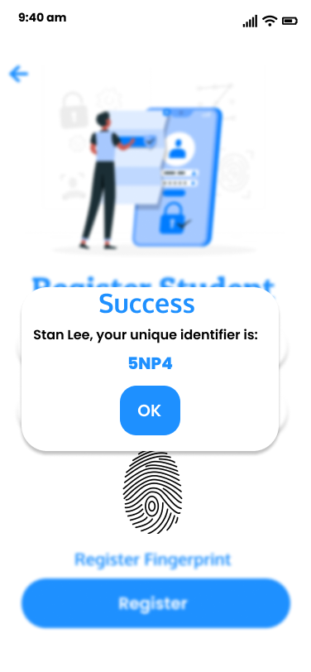

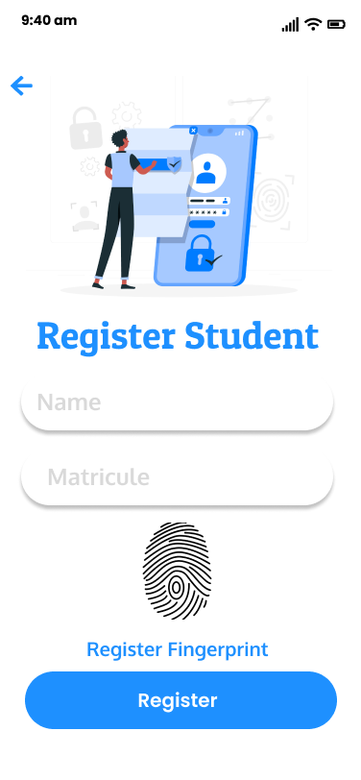

1. **Report Generation Screen**

This screen allows the admin to generate attendance reports based on a query selection placed in text inputs in the screen. This screen will do the following

* Attendance records are generated will be presented in a table from the queries
* Attendance reports can be shared.
* Attendance reports can be converted to PDF.
* Attendance reports can be exported to Excel Sheets.
* Attendance reports can be downloaded as a document for lecturers.

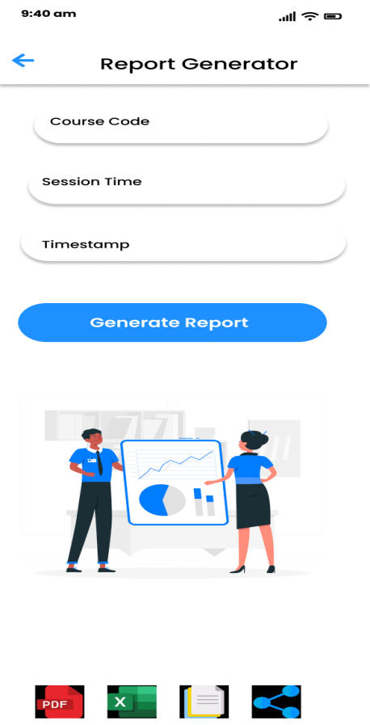

1. **Student Screens**
2. **Session Select Screen**

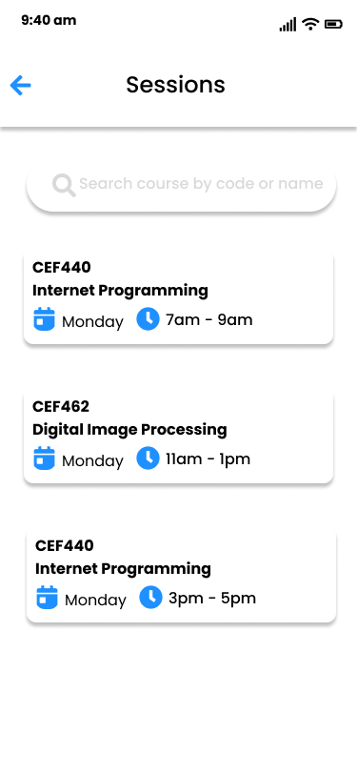

This screen enables the following properties

* Selection of courses
* Search courses

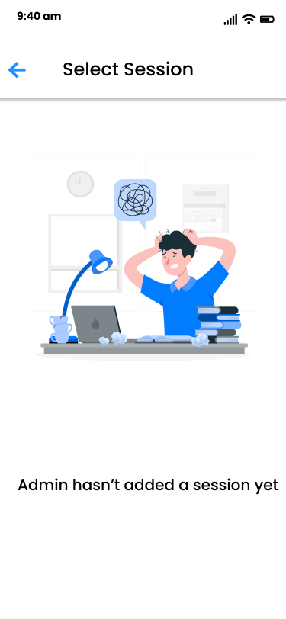

Select Sessions Screen

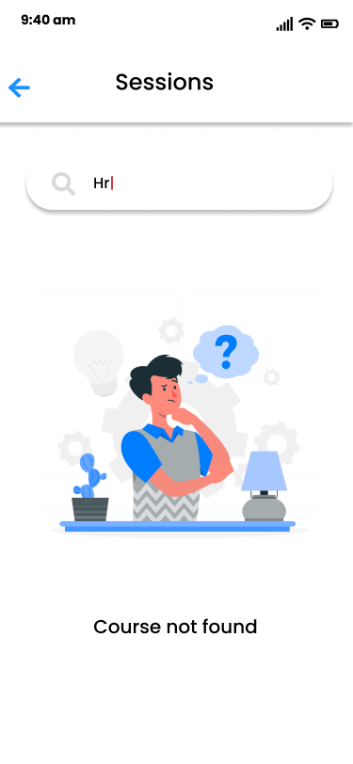

No Sessions Yet Screen

No Search Session Results Screen

1. **Take Attendance Screen**

For the take attendance screen, after selecting a session, a student has to enter the unique identifier given to him and the places his registered fingerprint on the scanner to mark attendance.

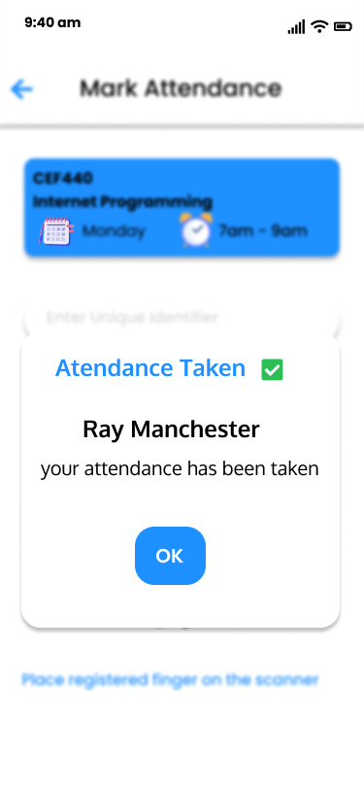

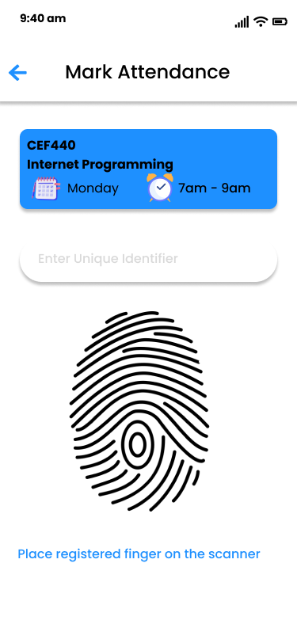

1. **Conclusion**

With the UI and UX set in place, frontend development can commence and later on followed up by database design accompanied by backend development. User Interface and User Experience Design plays a vital role in designing a system according to the specifications of the target usersso as to commence the implementation phase.